Project Report
On
Climate Scope: Visualizing Global Weather Trends and Extreme Events

Name: Gaurav Chauhan
Mentor Name: Shanmukha Priya
Date: April 2026

Authorship and Acknowledgement

This report presents the design, development, and analytical value of the ClimateScope platform developed during my internship as a Data Science Intern. The project was aimed at transforming raw global weather data into a structured, interactive, and professionally designed climate intelligence dashboard.
The report documents the problem context, objectives, technical architecture, implementation methodology, analytical modules, business-oriented extensions, and overall outcomes of the project.

Contents
1. Abstract 4
2. Introduction 5
3. Problem Statements 6
4. Project Objectives 7
5. Technology Stack and Architecture 8
5.1 Core Technologies 8
5.2 System Architecture 9
6.Dataset and Data Preparation 10
7. Methodology 11
8.Dashboard Modules 12
8.1 Executive Overview 12
8.2 Temperature Intelligence 13
8.3 Precipitation and Wind Intelligence 14
8.4 Extreme Events Monitor 15
8.5 Regional Comparison 16
8.6 Climate Risk Intelligence 17
8.7 Predictive Climate Analytics 18
8.8 Economic Impact Model 19
9. Implementation Details 20
10. Key Features Implemented 22
11. Results and Analytical Insights 23
12. Business Value and Practical Significance 24
13. Challenges Faced 25
14. Learning Outcomes 26
15. Conclusion 27
16. Future Scope 28

1. Abstract
Global climate and weather data are often large, fragmented, and difficult for decision-makers to interpret directly. Traditional dashboards usually focus on descriptive reporting, such as historical temperature plots, without offering deeper analytical insight, future forecasting, or practical business interpretation.
The objective of this project was to design and develop ClimateScope, a full-stack climate intelligence dashboard that integrates data processing, interactive visualization, predictive analytics, and impact-based interpretation into a single unified platform. The system was built using Python, Pandas, NumPy, Plotly, and Streamlit, along with custom CSS-based styling for an enterprise-grade interface.
The platform includes modules for climate overview, temperature intelligence, precipitation and wind analysis, extreme event monitoring, regional comparison, climate risk scoring, predictive temperature forecasting, and an economic impact model. Together, these modules demonstrate how meteorological data can be transformed into meaningful decision-support analytics.

2. Introduction

Climate data is complex and difficult to interpret without proper tools. Traditional dashboards often provide static reports but lack interactivity, forecasting, and real-world applicability.
The objective of ClimateScope was to build a fully interactive and scalable climate analytics platform that enables users to:
- Explore global weather trends
- Compare regional climate conditions
- Detect extreme events
- Analyze climate risk
- Predict future temperature behavior
- Understand business impact
Additionally, the system was enhanced with real-time data updates and cloud deployment, making it closer to a production-level application

3. Problem Statements

Climate datasets contain valuable information about global weather patterns, but their practical interpretation remains challenging. While raw data may describe temperature, rainfall, wind, humidity, and time, it does not automatically answer higher-level questions relevant to analysis or decision-making.
Typical dashboards often present static charts, but they may not help users answer questions such as:
- Which countries are currently experiencing the highest temperatures?
- How do precipitation and wind patterns vary across regions?
- Which regions are more exposed to extreme weather events?
- How can climate indicators be translated into broader risk or business impact?
- What future trends may emerge if current patterns continue?
These limitations highlight the need for an interactive climate intelligence platform that not only visualizes weather data, but also interprets it through forecasting and applied risk perspectives.

4. Project Objectives
The key objectives of the project were:
- To preprocess and structure global weather data
- To build an interactive multi-page dashboard
- To visualize temperature, precipitation, wind, and extreme events
- To implement interactivity using filters and selectors
- To develop a climate risk scoring system
- To add predictive analytics for future trends
- To translate climate data into business-oriented insights
- To integrate real-time data updates using Kaggle API
- To deploy the dashboard as a live web application using Render

5. Technology Stack and Architecture

5.1 Core Technologies
The project was developed using the following technologies:
Data Engineering and Processing
- Python
- Pandas
- NumPy
Statistical Modeling
- SciPy
- NumPy polynomial fitting functions
Web Framework
- Streamlit
Data Visualization
- Plotly Express
- Plotly Graph Objects
Data Integration
- Kaggle API (real-time dataset synchronization)
Deployment
- Render (cloud hosting platform)
Data Source
- Global Weather Repository dataset
- Kaggle-based dataset synchronization logic for updates
These tools were chosen because they support efficient data preprocessing, interactive visualization, statistical modeling, and rapid application development.

5.2 System Architecture
The application follows a modular multi-page dashboard architecture.
The key architectural layers are:
1. Data Ingestion Layer
This layer is responsible for acquiring and updating weather data, including scripts for fetching and preparing the latest dataset.
2. Processing and Transformation Layer
This layer handles data cleaning, schema preparation, datetime conversion, aggregation, and feature engineering.
3. Dashboard State Management Layer
The main application manages global configuration, page rendering, theme styling and,shared UI behavior.
4. Analytical Module Layer
Each dashboard page acts as a dedicated analytical module focused on a specific domain such as extreme events, forecasting, or business impact.
5. Deployment Layer
Streamlit application hosted on Render
Web-accessible interface for users
This architecture made the project modular, scalable, and easier to maintain.

6.Dataset and Data Preparation

The dashboard is built on a global weather dataset containing country-level weather attributes across time. The key variables include:
- Country
- Last updated / date field
- Temperature in Celsius
- Precipitation in millimeters
- Wind speed in kilometers per hour
- Humidity
- Derived year and month fields
Before visualization and analysis, the dataset was preprocessed through the following steps:
- Loading the raw CSV data
- Inspecting schema and column structure
- Handling missing and inconsistent values
- Converting date fields into datetime format
- Extracting year and month for temporal analysis
- Aggregating observations where necessary for monthly and yearly trends
- Creating derived metrics for extreme event detection and risk analysis
This preparation stage ensured that the dataset was reliable and analysis-ready for all dashboard modules.

7. Methodology
The project followed a structured development methodology:
7.1 Data Collection
The weather dataset was obtained and prepared for use in the application.
7.2 Data Cleaning and Transformation
Schema validation, null handling, datetime conversion, and derived fields were prepared.
7.3 Exploratory Data Analysis
Initial analysis was carried out to study distributions, correlations, seasonal patterns, and country-level differences.
7.4 Dashboard Design
Wireframe planning and module-based page design were used to organize the analytical structure.
7.5 Visualization Development
Charts, maps, heatmaps, comparison plots, and ranking visuals were implemented using Plotly.
7.6 Interactivity Integration
Filters, selectors, sliders, and comparison tools were added to make the dashboard dynamic.
7.7 Advanced Module Integration
Forecasting and economic impact modeling were then added to extend the dashboard beyond descriptive climate analysis.

8.Dashboard Modules
The ClimateScope platform was organized into multiple analytical pages. Each page was designed for a specific purpose.

8.1 Executive Overview
The Executive Overview page provides a high-level summary of global climate conditions. It includes key performance indicators such as:
- Global Average Temperature
- Temperature Year-on-Year Change
- Total Precipitation
- Average Wind Speed
- Extreme Events Count
- Hottest Country
This page is intended for rapid interpretation and executive-style monitoring. It also includes a choropleth map, trend charts, and ranking visuals.
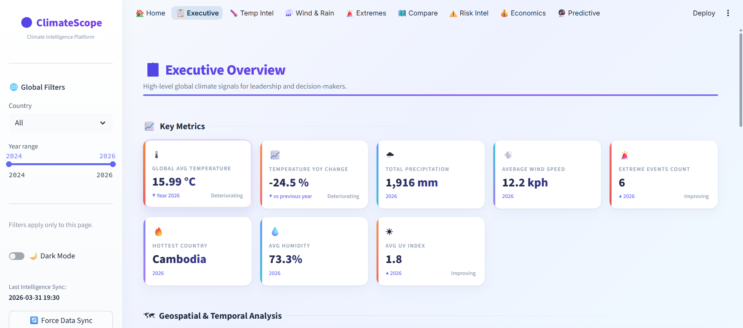

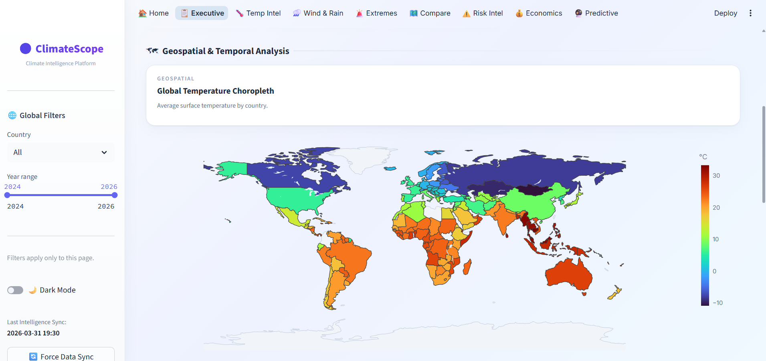

8.2 Temperature Intelligence
This module focuses on temperature analytics and includes:
- Current average temperature
- Maximum and minimum temperatures
- Temperature anomaly indicator
- Monthly and yearly time-series trends
- Seasonal heatmap
- Temperature distribution histogram
- Multi-country comparison line chart
The aim of this page is to analyze temporal and regional temperature behavior in detail.
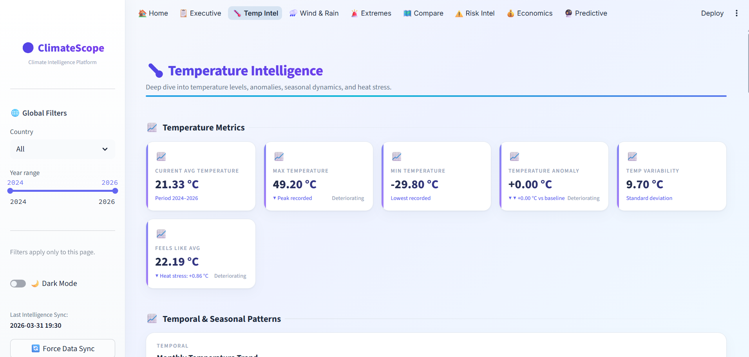

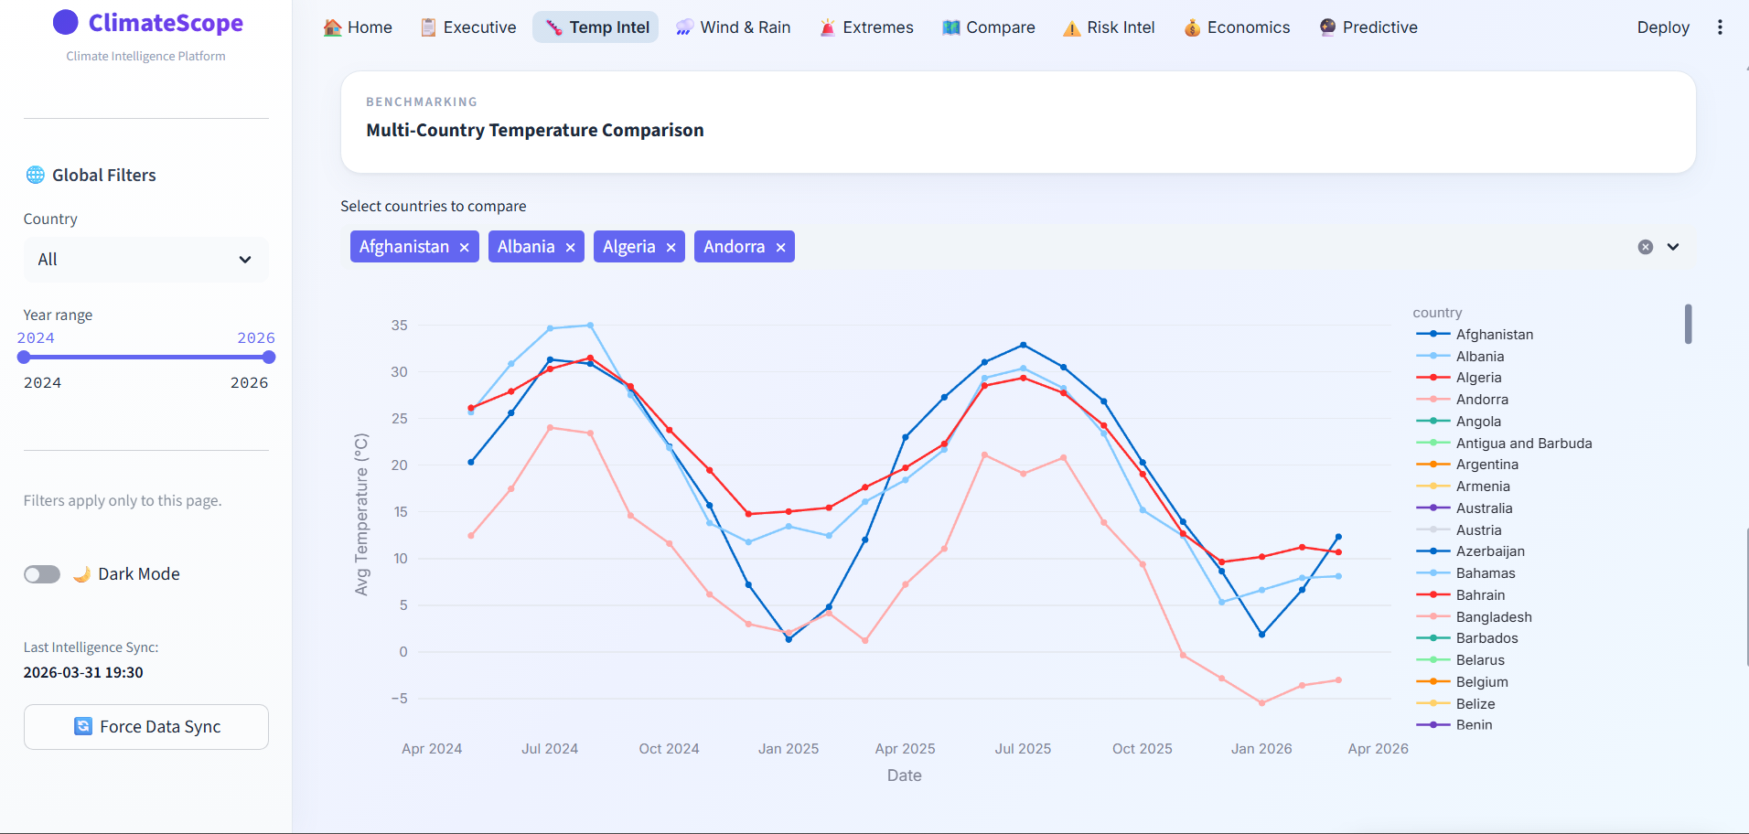

8.3 Precipitation and Wind Intelligence
This page examines rainfall and wind patterns. It includes:
- Total rainfall
- Heavy rain days
- Average wind speed
- High wind events
- Rainfall variability index
- Rainfall trend lines
- Wind speed trends
- Rain vs wind scatter plots
- Country ranking charts
This module helps identify atmospheric variability and relationships between precipitation and wind intensity.
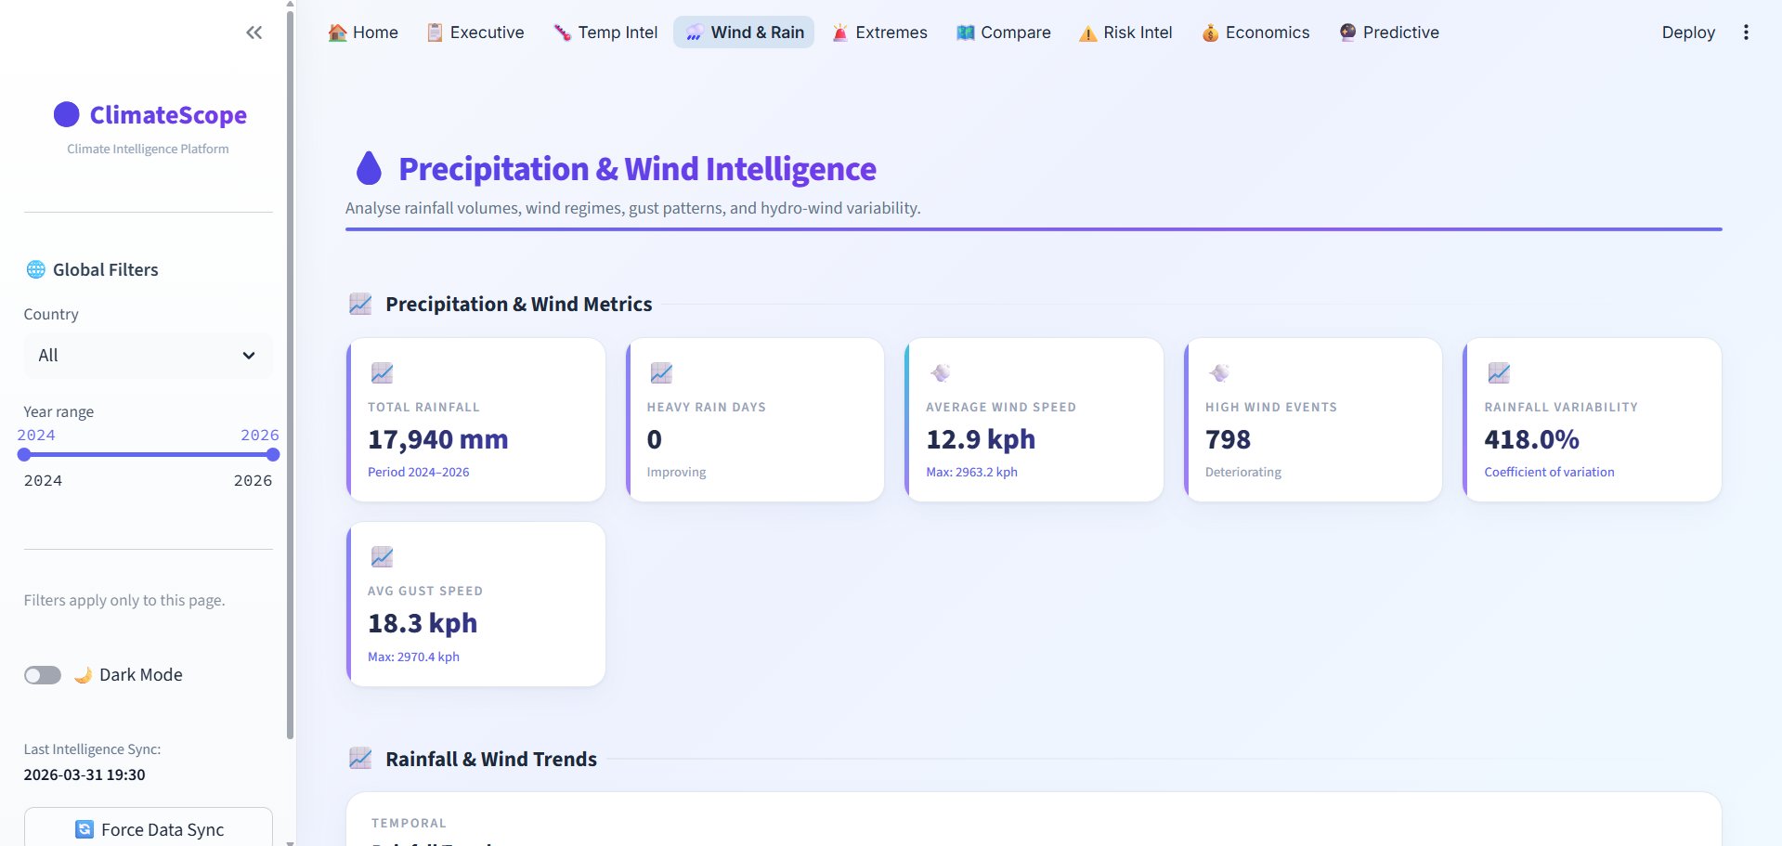

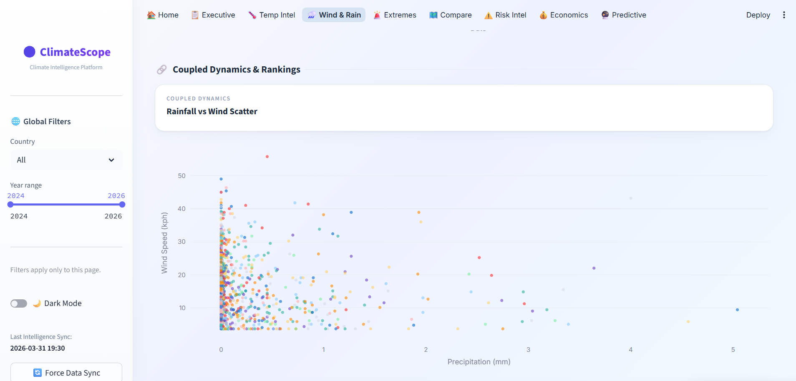

8.4 Extreme Events Monitor
The Extreme Events Monitor uses predefined thresholds to identify:
- Heatwaves
- Heavy rainfall events
- High wind events
It includes:
- Total extreme events
- Heavy rain event counts
- High wind event counts
- Highest risk country
- Event timeline
- Country-wise event map
- Monthly heatmap
This module supports climate alert analysis and region-wise event tracking.
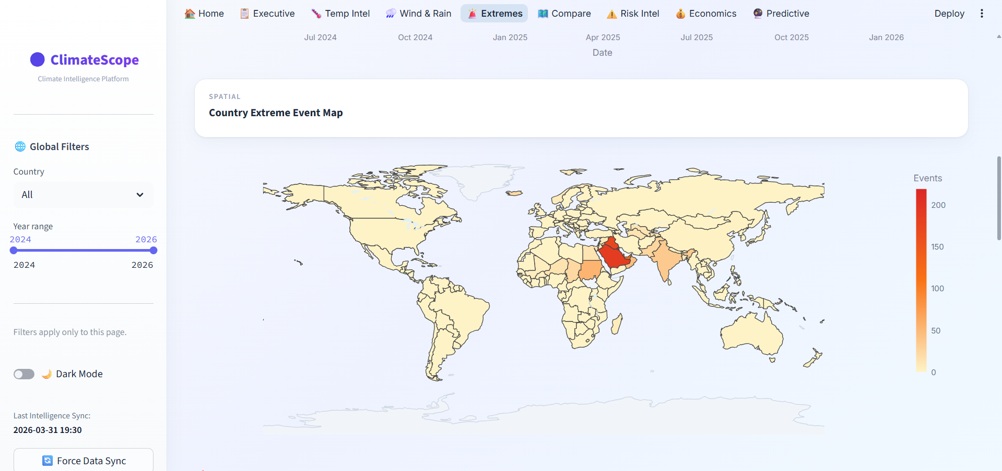
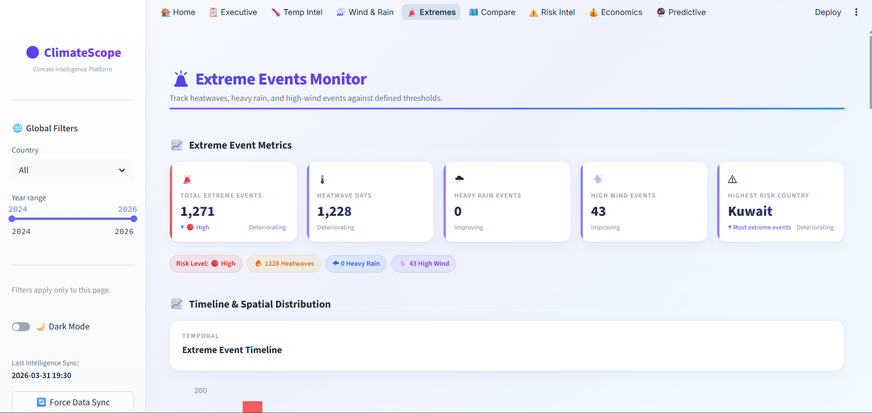

8.5 Regional Comparison
This page enables side-by-side comparison of two selected countries. It includes:
- Country A average temperature
- Country B average temperature
- Temperature difference
- Rainfall difference
- Wind difference
- Dual comparison line charts
- Grouped bar charts
- Radar chart comparison
- Regional ranking
This page helps users benchmark countries against one another across multiple climate indicators.
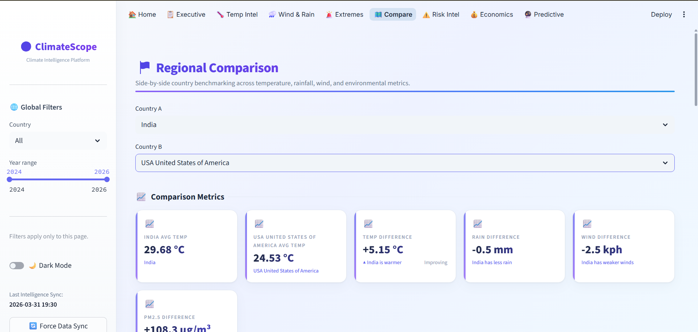

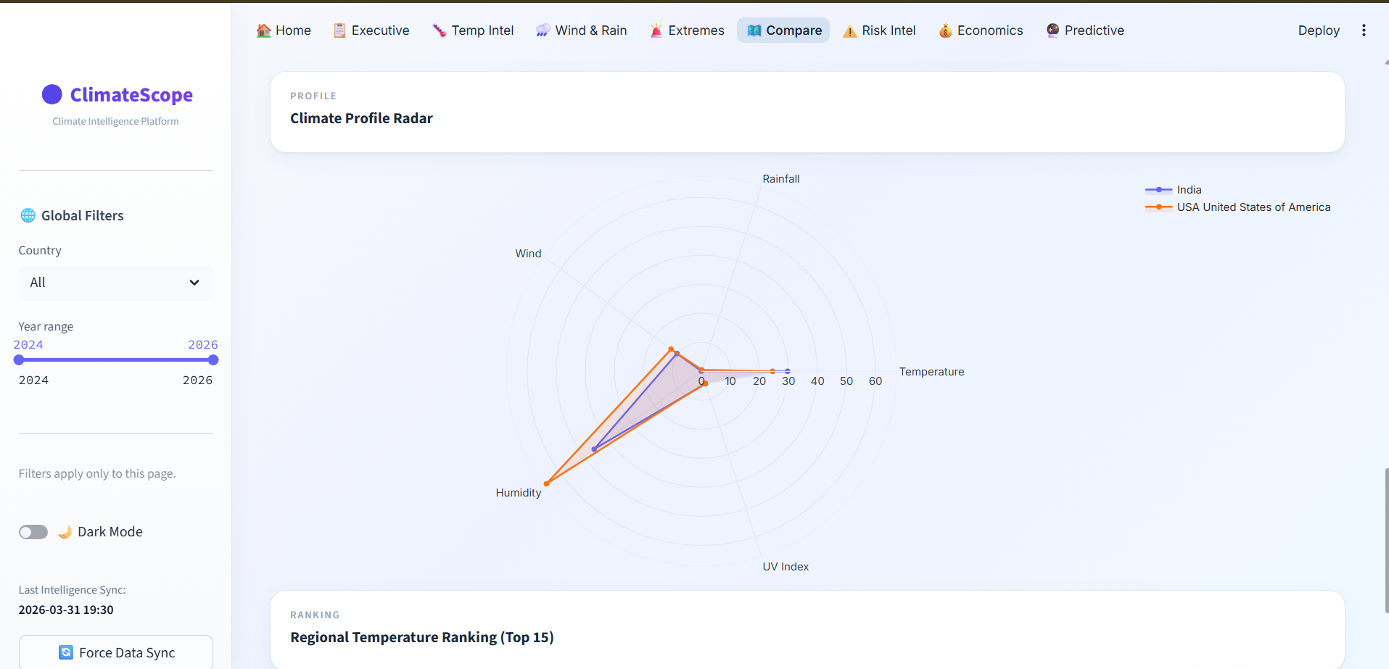

8.6 Climate Risk Intelligence
This module combines climate variables into a composite climate risk score and presents:
- Climate risk score
- Risk category
- Volatility index
- Trend direction
- Risk score by country
- Risk trend over time
- Risk heatmap
- Top 10 risk countries
The purpose of this page is to summarize multi-dimensional climate risk into an interpretable decision-support metric.
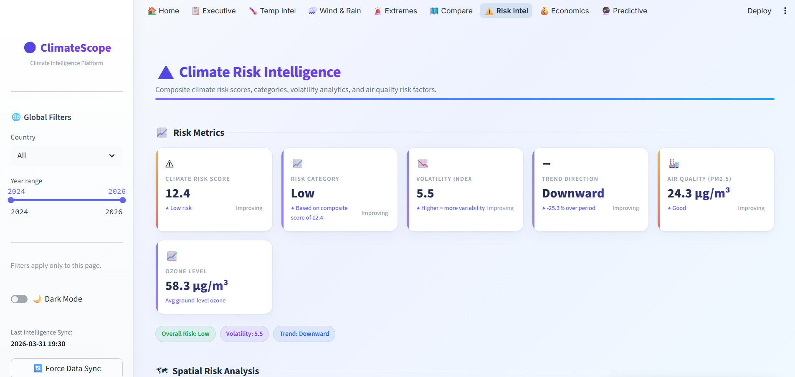

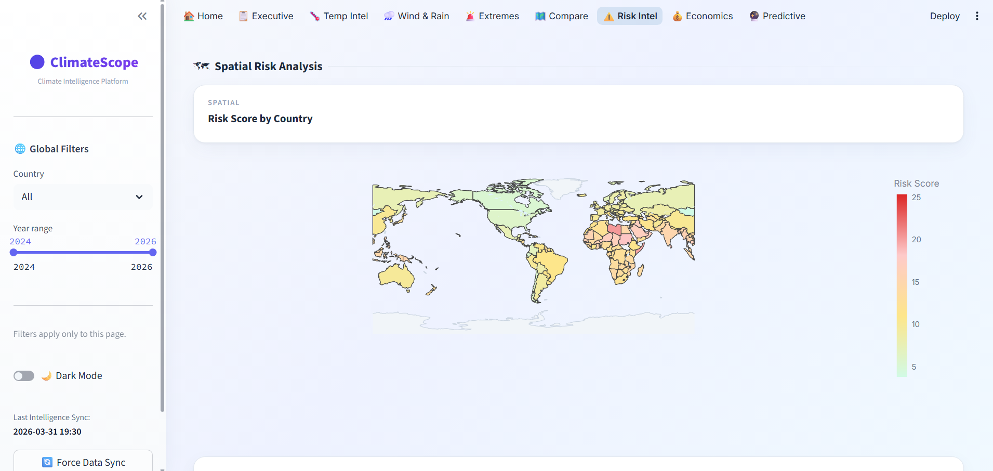

8.7 Predictive Climate Analytics
A new page named 7_Predictive_Analytics.py was added to support future-oriented analysis. This module uses Polynomial Regression Modeling to forecast temperature trajectories into future periods.
The module includes:
- Historical temperature trend fitting
- Future temperature projection
- A simulated confidence interval
- Visual uncertainty representation through an expanding forecast band
The confidence interval is displayed as a cone-like uncertainty region, which communicates the increasing uncertainty associated with longer-term forecasts. This gives the forecasting module more analytical depth and realism.

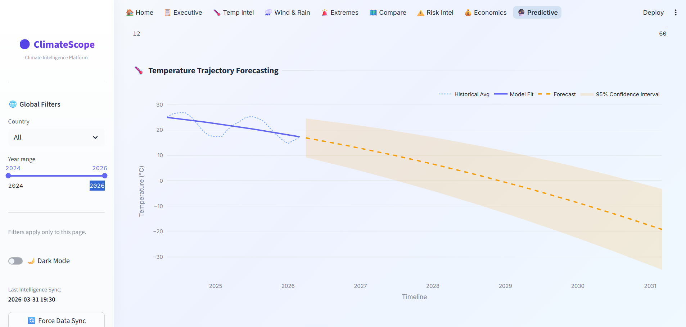

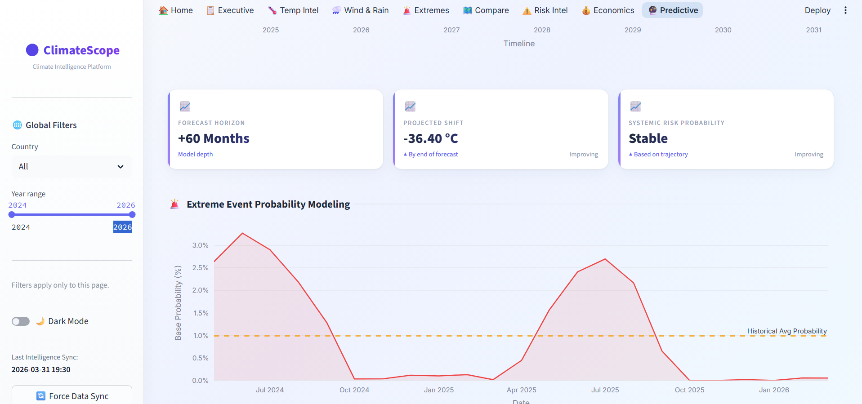

8.8 Economic Impact Model
A second advanced page named 8_Economic_Impact_Model.py was also added. This module translates weather variables into more practical, business-oriented metrics.
It estimates:
- Supply Chain Disruption Days
- Infrastructure Exposure Risk
- Agricultural Yield Volatility
The page also features a correlation matrix heatmap to show the relationships between weather indicators and the derived economic risk measures. This expands the dashboard from environmental analysis toward climate-informed business intelligence.
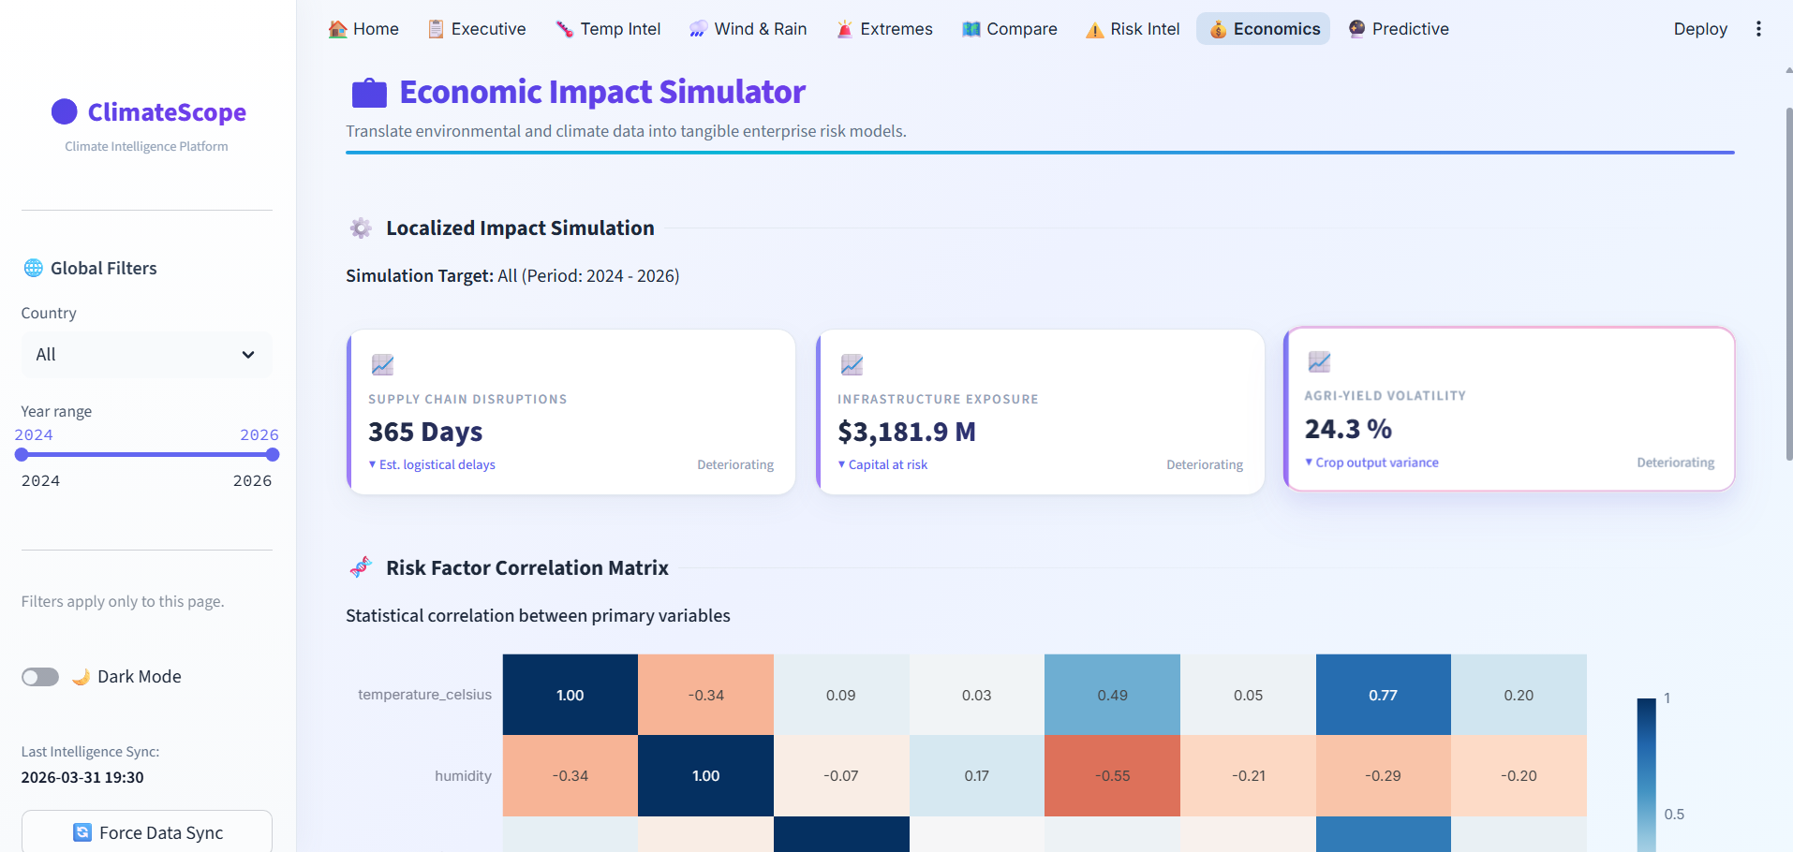

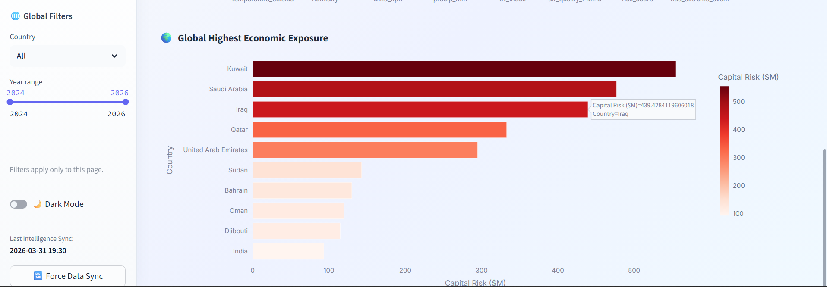

9. Implementation Details
Automated Data Pipeline
To support updated data usage, the project includes logic for synchronizing the dataset from a repository source. The intended workflow is:
- Connect to the source repository
- Download the dataset
- Parse the CSV file
- Perform date conversion and schema preparation
- Save the cleaned data as the active dashboard source
This pipeline concept supports easier updating of the dashboard with newer data versions.
Example logic used in the project includes repository download, CSV loading, datetime parsing, and saving the cleaned file for application use.
Predictive Modeling Logic
The Predictive Climate Analytics page uses 2nd-degree polynomial regression to model the temperature trend. Historical dates are converted into numeric ordinal values, and the model is fitted to those observations.
Future dates are then generated and passed through the fitted polynomial model to estimate future temperatures. Residual spread is used to simulate a 95% confidence interval band around the forecast.
This approach provides an accessible forecasting method while remaining interpretable for presentation purposes.
Economic Translation Logic
The Economic Impact Model computes derived business-risk indicators based on climate measures such as risk score, event frequency, and temperature variability. The model estimates disruption days, exposure risk, and agricultural volatility through mathematical transformation logic.
Although these outputs are modeled estimates rather than externally validated financial predictions, they demonstrate how environmental analytics can be translated into applied decision-support indicators.
Advanced UI Engineering
An important part of the project was dashboard presentation quality. The user interface was enhanced using custom CSS and Plotly layout wrappers to create a more professional appearance.
Key UI improvements include:
- KPI cards with improved spacing and visual hierarchy
- Transparent and theme-aware Plotly chart backgrounds
- Better typography and layout consistency
- Cleaner chart integration across modules
These improvements made the dashboard more polished and presentation-ready.

10. Key Features Implemented
The completed platform includes the following major features:
- Interactive multi-page dashboard architecture
- Country and year filtering
- KPI cards for summary indicators
- Geospatial choropleth maps
- Time-series analysis for temperature, rainfall, and wind
- Seasonal heatmaps and distribution analysis
- Extreme event monitoring
- Regional comparison analytics
- Climate risk scoring
- Predictive forecasting using polynomial regression
- Economic impact simulation metrics
- Correlation matrix heatmap for risk relationships
- Real-Time Data Integration
- Dashboard was deployed using the Render platform
These features together make ClimateScope a broad and capable climate analytics platform.

11. Results and Analytical Insights

The platform generated several important findings from the climate data:
- Temperature variability differs significantly across regions
- Seasonal patterns are visible in monthly and yearly trends
- Rainfall behavior is highly uneven across countries
- High wind conditions appear concentrated in selected regions
- Extreme events are more frequent in some climate zones than others
- Composite climate risk scores highlight relatively higher-risk countries
- Forecast models provide a directional view of possible future temperature movement
- Impact simulation helps connect climate indicators with practical risk-oriented interpretation
These results show that the dashboard is useful not only for descriptive monitoring, but also for comparative, predictive, and applied analysis.

12. Business Value and Practical Significance
ClimateScope demonstrates how raw meteorological data can be converted into a professional decision-support platform.
The project provides value by enabling users to:
- Understand global and regional climate behavior
- Detect high-risk environmental patterns
- Explore future trend possibilities
- Relate weather indicators to broader operational concerns
- Communicate data insights effectively through an interactive dashboard
The inclusion of the Predictive Analytics page and the Economic Impact Model strengthens the platform’s practical relevance by supporting both future-oriented thinking and business-context interpretation.
From an internship perspective, the project demonstrates end-to-end capability across:
- Data preprocessing
- Interactive analytics
- Visualization engineering
- Forecasting logic
- UI design
- Applied decision-support modeling

13. Challenges Faced
Several technical and design challenges were encountered during the project:
- Managing multiple weather indicators within a clear dashboard structure
- Designing pages that remain readable despite many KPIs and charts
- Building meaningful derived metrics from raw weather variables
- Adding forecasting without making the model opaque or overly complex
- Translating environmental data into practical business-style indicators
- Refining UI design beyond default dashboard templates
These challenges were addressed through repeated iteration, modular development, and improvement of both analytical logic and user experience.

14. Learning Outcomes

This project significantly improved my practical understanding of:
- Data preprocessing and feature preparation
- Exploratory data analysis
- Plotly-based interactive visualization
- Streamlit multi-page dashboard development
- Regression-based forecasting concepts
- Risk-based analytical thinking
- Business-oriented presentation of technical outputs
- UI enhancement through custom styling
It also strengthened my ability to develop a project from raw data to final presentation-quality application.

15. Conclusion

The ClimateScope project successfully achieved its core objective of transforming raw weather data into a professional climate intelligence dashboard.
The final system evolved beyond a standard analytical dashboard by including:
- Descriptive climate monitoring
- Interactive visual exploration
- Regional comparison
- Composite climate risk analytics
- Predictive forecasting
- Business-oriented impact simulation
The addition of Predictive Climate Analytics and the Economic Impact Model significantly increased the scope and sophistication of the project. Together, these modules helped turn ClimateScope into a broader climate intelligence platform with both analytical depth and practical relevance.
This internship project demonstrates my ability to work across the full stack of a data product, from preprocessing and analysis to visualization, forecasting, and UI design.

16. Future Scope

Possible future enhancements include:
- Using more advanced time-series forecasting models
- Validating the impact model against external business datasets
- Adding automated report generation from dashboard outputs
- Integrating additional climate and environmental variables
- Expanding forecasting to rainfall, wind, and risk-score prediction
These improvements could make the platform more robust and closer to real-world deployment.

